**Lab Exercise 04**

**Executing Ansible Modules**

Jahnavi Anand

500106908

**Objective:** To demonstrate the use of the Ansible module for server configuration and management

**Tools required:** Linux terminal

**Prerequisites:** None

Steps to be followed:

1. Use Ansible modules for server configuration

**Step 1: Use Ansible modules for server configuration**

1. 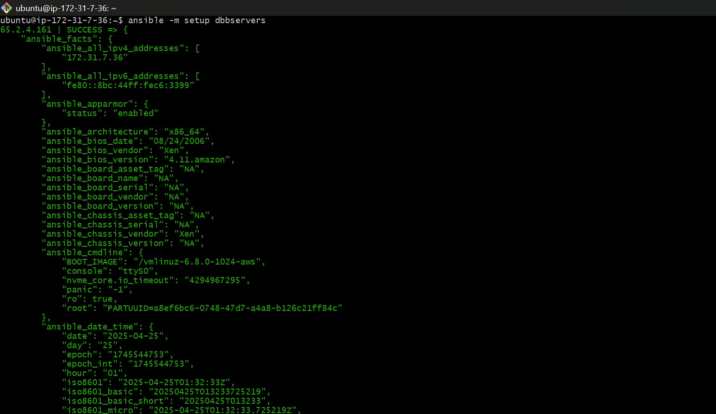Run the following command using the **setup** module to collect and display detailed system information about the servers:   
   **ansible -m setup dbservers**

1. Run the following command using the **shell** module to retrieve server hostnames:  
   **ansible dbservers -m shell -a ‘hostname’**

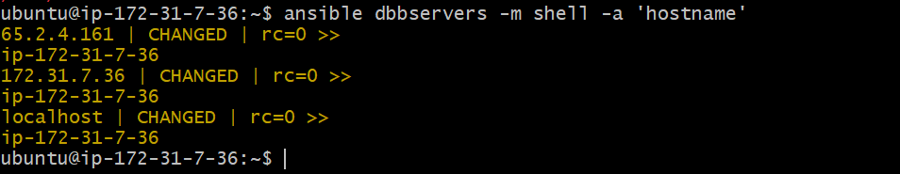

1. 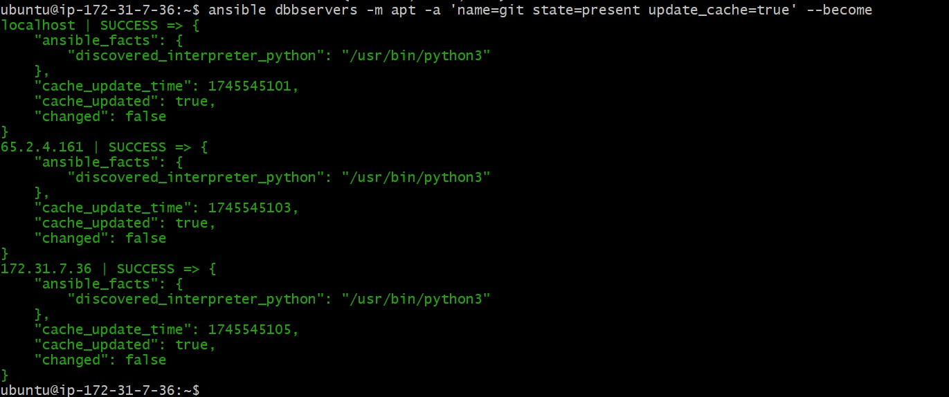Run the following command using the **apt** module to install Git on servers:  
   **ansible dbservers -m yum -a 'name=git state=present' - - become**